eCR Now Setup Instructions – windows

# **Prerequisites**

* **docker-desktop to be installed in your system**
* **ecr-now.zip shared by our team with env & other files.**

## System Requirements for adding docker-desktop in windows

* **Operating System**: Windows 10 64-bit: Pro, Enterprise (Build 15063 or later)
* **Hyper-V and Containers Windows features must be enabled**
* **WSL 2 (Windows Subsystem for Linux) backend is recommended**
* **Hardware**: Minimum 4GB RAM, BIOS-level hardware virtualization support

## **Downloading Docker Desktop**

1. Open your preferred web browser.
2. Navigate to the Docker Desktop download page: Docker Desktop for Windows.
3. Click on the **"Download for Windows"** button.

## **Installing Docker Desktop**

* 1. Locate the downloaded installer (Docker Desktop Installer.exe) and double-click to run it.
  2. Follow the on-screen instructions in the Docker Desktop Installer.
  3. When prompted, ensure the following options are checked:
  4. **"Enable Hyper-V Windows Features"**
  5. **"Install required Windows components for WSL 2"**
  6. Click on **"OK"** and proceed with the installation.
  7. Once the installation is complete, click on **"Close and restart"** to restart your computer.

## **Verifying Configuration**

1. After restarting, launch Docker Desktop from the Start menu or desktop shortcut.
2. When Docker Desktop starts for the first time, it will prompt you to sign in to Docker Hub. You can create a new account if you don't have one or skip this step.
3. Docker Desktop will prompt to use WSL 2. If WSL 2 is installed, select it; otherwise, follow the instructions to install WSL 2.
4. Docker Desktop will start and show the status in the taskbar.
5. Open Command Prompt or PowerShell.
6. Run the following command to check Docker version

**docker --version**

Run the following command to check Docker Compose version

**docker-compose –version**

## **Application Setup with Docker**

**Step: 1 Creating a docker network**

Create a docker network on the name of ecrnow_network**,** use below command:

docker network create ecrnow_network

**Step: 2 Run PostgreSQL Container**

Run the PostgreSQL container with the specified network and environment variables, use below command:

docker run -d --network ecrnow_network --name postgres_container --restart always -e POSTGRES_PASSWORD=ecrnow@2024 -p 5432:5432 postgres:15

Note: Add password of your choice  
  
***Step: 3 Run PgAdmin Container***

1)Run PgAdmin Container:

docker run -d --network ecrnow_network --name pgadmin-container -p 5050:80 -e PGADMIN_DEFAULT_EMAIL=user@domain.com -e PGADMIN_DEFAULT_PASSWORD=postgres -d dpage/pgadmin4

Remember to replace [user@domain.com](mailto:user@domain.com) and postgres with your actual email and password.

This command runs PgAdmin in a Docker container (dpage/pgadmin4) on port 5050. It sets the default login credentials ([user@domain.com](mailto:user@domain.com) and postgres).  
  
  
 2) Refer this link Connecting PostgreSQL Container using PgAdmin 4

**Step: 4 Create ecrnow Database**

**If the “ ecrnow” database is created using PgAdmin in Step 3, you can skip this step**.

Execute the following command to create the **ecrnow** database inside the PostgreSQL container

docker exec -it postgres_container psql -U postgres -c "CREATE DATABASE ecrnow;"

**Step: 5 Setting up environment variables**

Unzip the ecr-now.zip place it in C- drive and go to env.list file inside ecr-now folder and adjust variables as shown below

LOGGING_FILE_LOC=/c/ecr-now/ecrNow.log

ESRD_FILE_LOC=/c/ecr-now/eRSDv2_specification_bundle.json

SCHEMATRON_FILE_LOC=/c/ecr-now/schematron/CDAR2_IG_PHCASERPT_R2_STU1.1_SCHEMATRON.sch

SCHEMA_FILE_LOC=/c/ecr-now/schemas/CDA_SDTC.xsd

KAR_DIRECTORY=/c/ecr-now/kars

BSA_OUTPUT_DIRECTORY=/c/ecr-now/bsa-output/

CUSTOM_QUERY_DIRECTORY=/c/ecr-now/custom-queries

DATABASE_URL=jdbc:postgresql://postgres_container:5432/postgres

### **Step: 6 Run eCR Now Backend**

Run the eCR Now backend container with the specified environment variables and volume mappings:

docker run -d --network ecrnow_network --restart always --env-file C:/ecr-now/env.list -e jdbc.username=postgres -e jdbc.password=ecrnow@2024 -e security.key=test123 --link postgres_container:postgres -v C://ecr-now:/c/ecr-now -p 8081:8081 --name ecr-now drajerhealth/ecr-now:ecr-now-3.1.4-postgres

Note: Add password used while creating postgres container and run above command

**Step: 7 Run eCR Now UI**

Run the eCR Now UI container with the specified environment variable:

docker run -d --network ecrnow_network --restart always -e REACT_APP_ECR_BASE_URL=http://localhost:8081 --name ecrNow-ui -p 3000:3000 drajerhealth/ecr-now:ecr-now-ui-3.1.4

**Go to browser and hit http://localhost:3000**

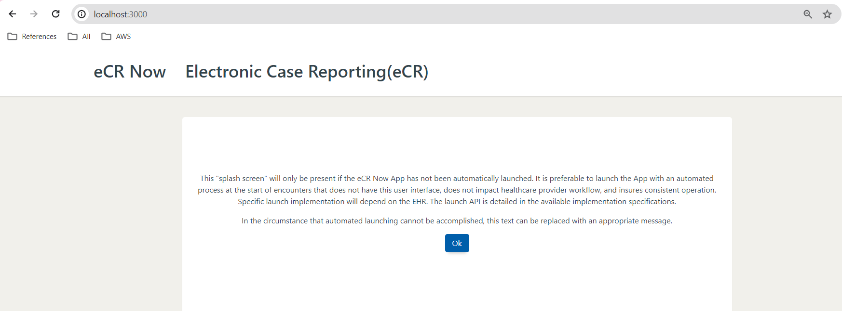

<http://localhost:3000/healthcaresettings>

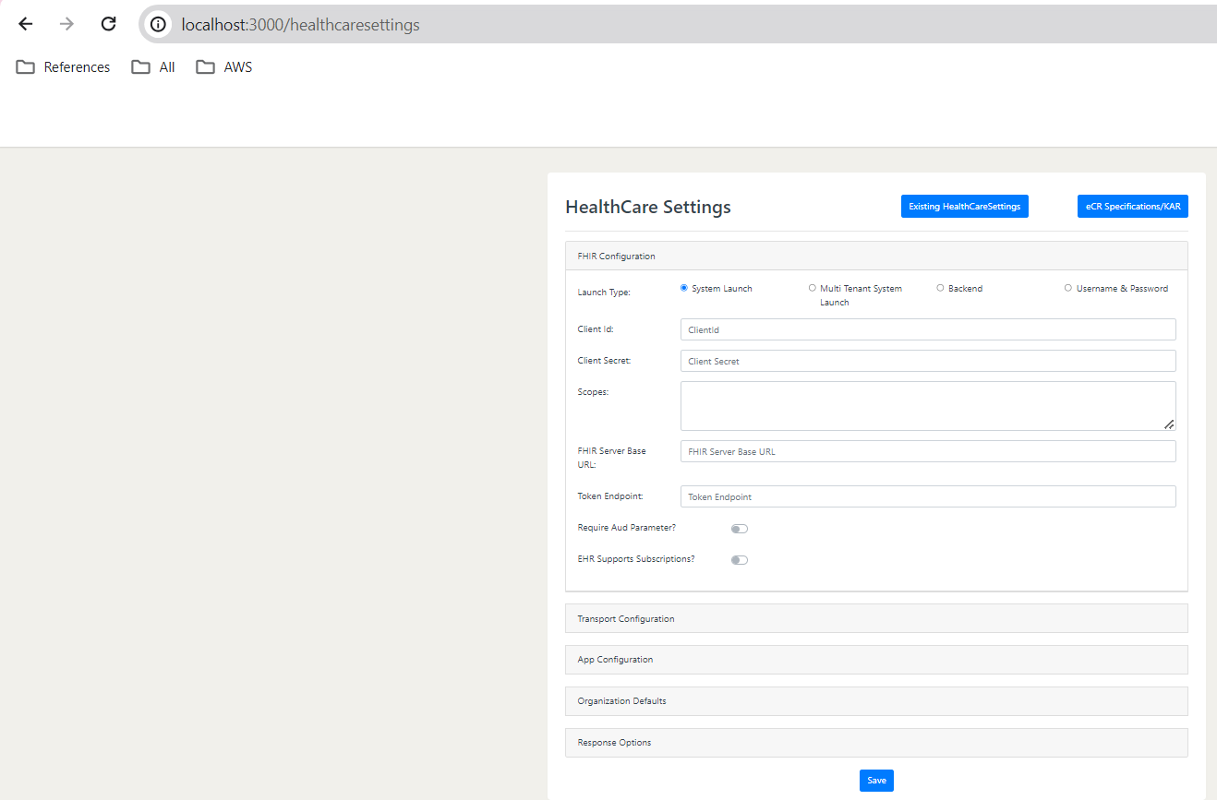

# Connecting to Database Container using pgAdmin 4

## Log in to pgAdmin 4

Once the container is successfully running (if you encounter any issues, it’s a good idea to check the Docker Desktop app to ensure the container is running), you can access pgAdmin by navigating to localhost:5050 in a web browser of your choice.

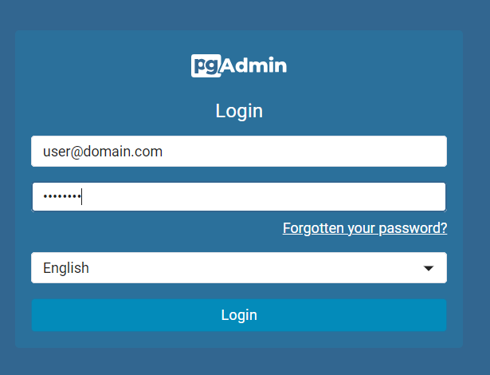  
  
  
You will then see a login prompt; you will be able to log in with the e-mail address and password that you specified previously when running the pg Admin Docker container

, in our case “user@domain.com” and “postgres”.

Note :-The username and password should be the same as those used when running the pg Admin Docker container.

## Connect to Database Container/ Add Server

In the next step, we are going to connect to the database container. For this, you need to click on Add New Server:

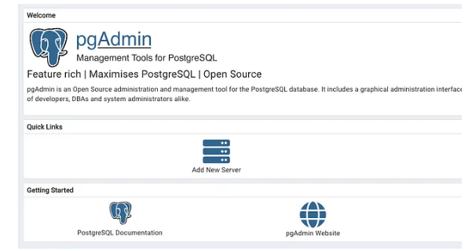  
  
And enter the relevant information to connect to our database, in the Name field we can choose an Alias to refer to our database in Pg Admin:  
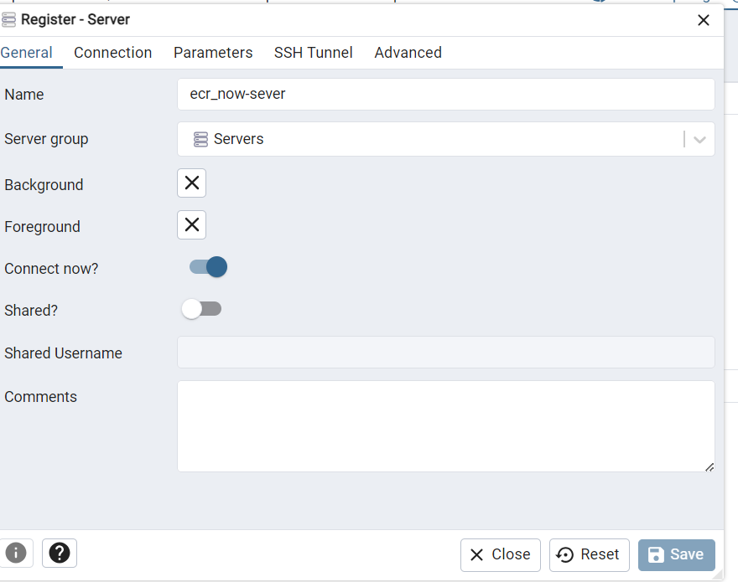

Before we proceed, it’s important to obtain the IP address of the “postgres” container. To find the IP address, you can execute the following command in your terminal (Linux/macOS) or PowerShell (Windows):

docker inspect -f '{{.NetworkSettings.Networks.ecrnow_network.IPAddress}}' postgres_container

In our case, it returned the IP address 172.17.0.3 (this may or may not be true for you). Now we enter all the connection information:

Host name/address: 172.17.0.3 (might be different for you)   
 or   
Host name/address: postgres_container (name of Postgres container)

Port: 5432 (port of postgres container)

Maintenance database: postgres

Username: postgres (or another name if you changed it)

Password: ecrnow@2024 (or whatever password you selected for Postgres container)

Optional: Set save password to true

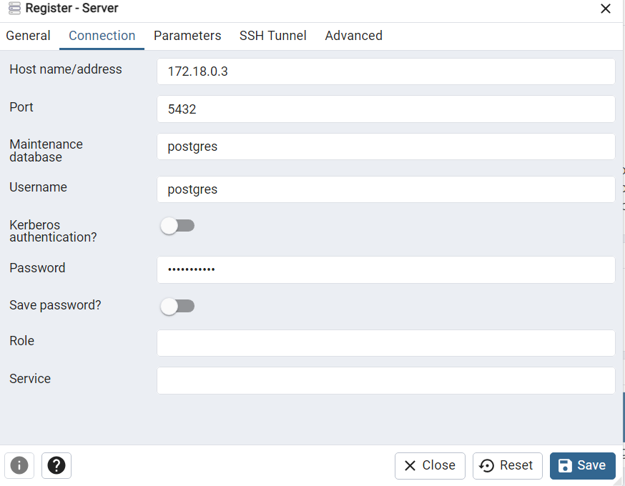

Click Save and you will be able to select your database server from the menu on the left side:  
  
  
  
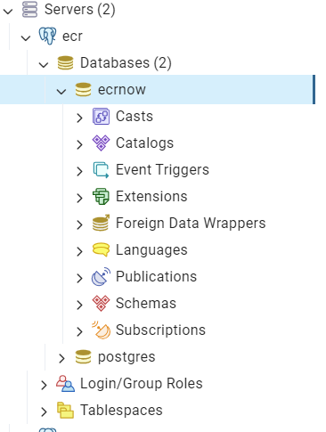  
  
Note:-Create the ecrnow database if database does not exist

Congratulations, now your environment should be up and running. For questions about pgAdmin 4 refer to the documentation:  
[PgAdmin Docs](https://www.pgadmin.org/docs/pgadmin4/development/index.html?source=post_page-----4a8d81048aea--------------------------------)